**WEEK -2 TASK**

**DO WHILE**

class Main{

public static void main(String[] args) {

int i = 1;

do {

System.out.println("Square of " + i + " is: " + (i * i));

i++;

} while (i <= 5);

}

}

OUTPUT :

Square of 1 is: 1

Square of 2 is: 4

Square of 3 is: 9

Square of 4 is: 16

Square of 5 is: 25

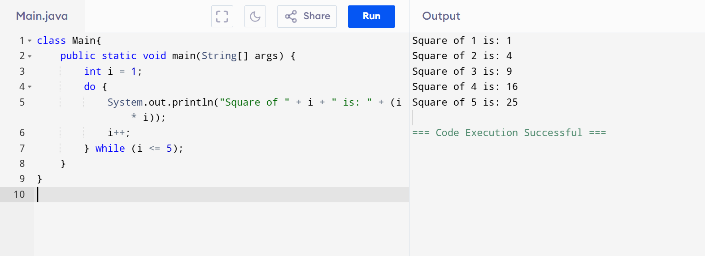

**Switch case:**

class Main{

public static void main(String[] args) {

int day = 3;

switch (day) {

case 1:

System.out.println("Monday");

break;

case 2:

System.out.println("Tuesday");

break;

case 3:

System.out.println("Wednesday");

break;

case 4:

System.out.println("Thursday");

break;

case 5:

System.out.println("Friday");

break;

case 6:

System.out.println("Saturday");

break;

case 7:

System.out.println("Sunday");

break;

default:

System.out.println("Invalid day");

}

}

}

**OUTPUT:**

Wednesday

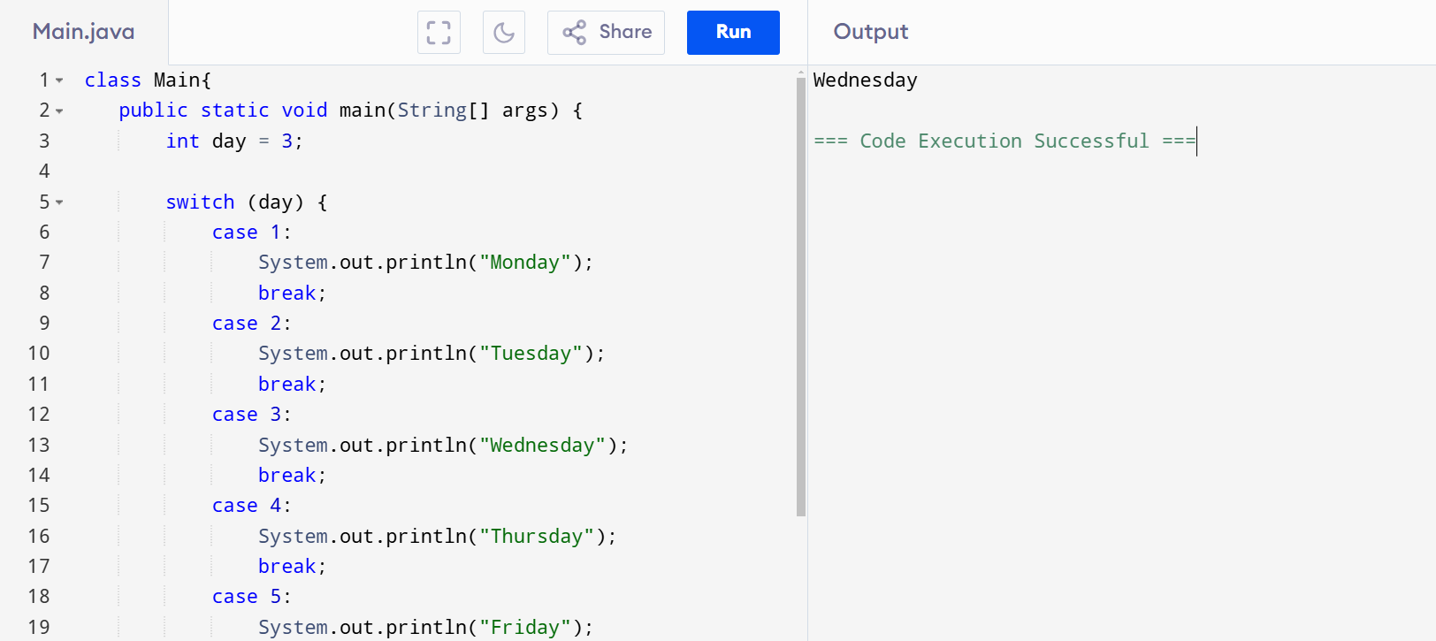

**WHILE LOOP**

class Main{

public static void main(String[] args) {

int i = 2;

while (i <= 20) {

System.out.println(i);

i += 2;

}

}

**}**

**OUTPUT**

2

4

6

8

10

12

14

16

18

20

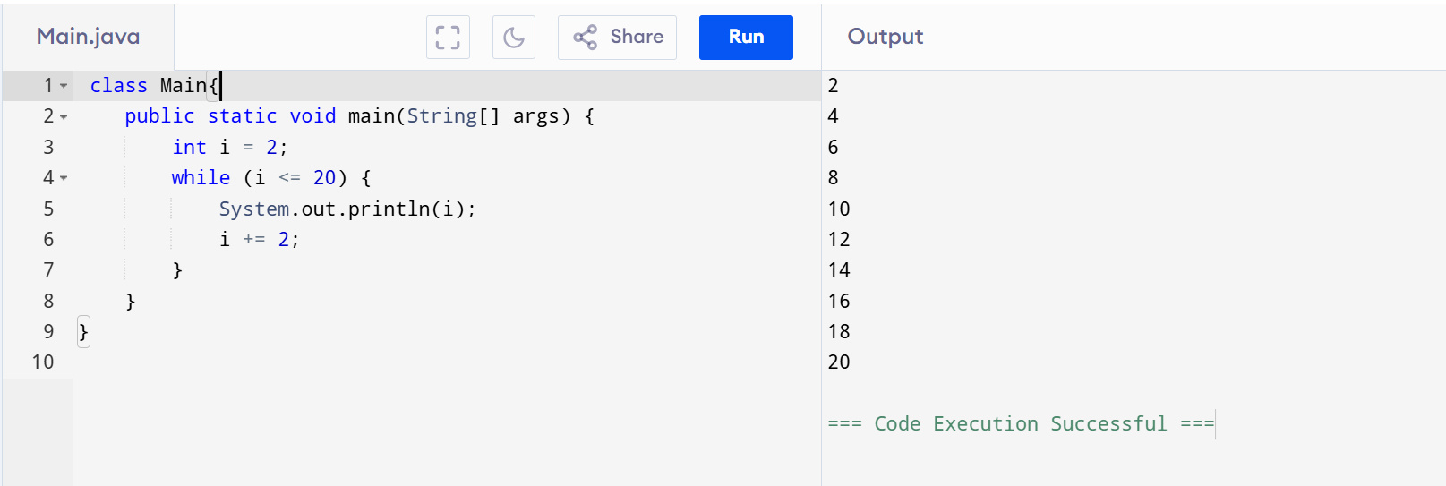

IF STATEMENT

class Main{

public static void main(String[] args) {

int number = 10;

if (number % 2 == 0) {

System.out.println("The number " + number + " is even.");

}

}

}

**OUTPUT:**

The number 10 is even.

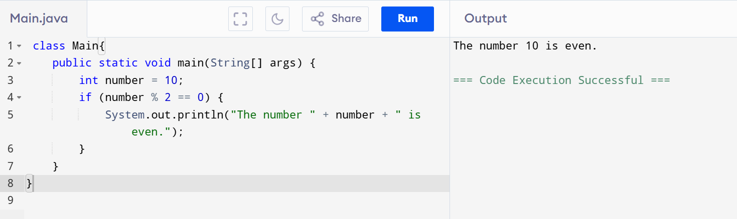

**IF ELSE STATEMENT**

class Main{

public static void main(String[] args) {

int number = 15;

if (number % 2 == 0) {

System.out.println("The number " + number + " is even.");

} else {

System.out.println("The number " + number + " is odd.");

}

}

}

**OUTPUT:**

The number 15 is odd.

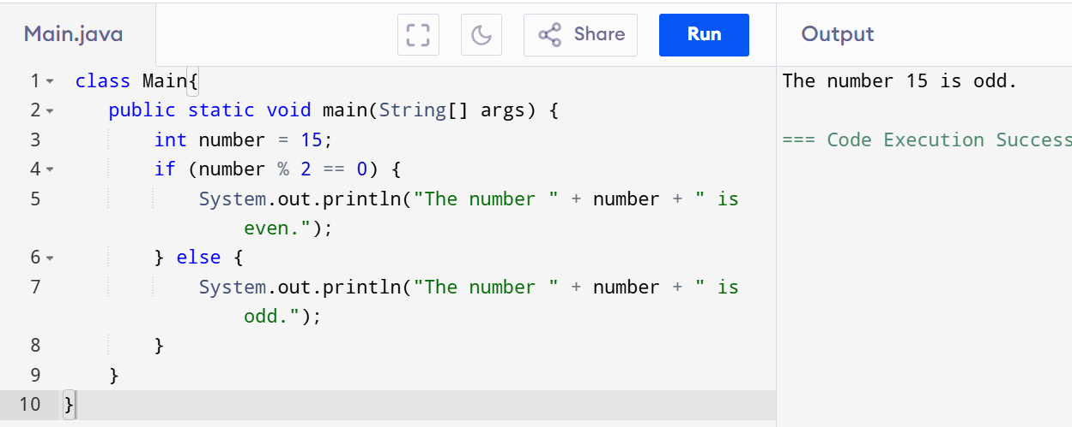

**IF-ELIF STATEMENT:**

class Main{

public static void main(String[] args) {

int number = -5;

if (number > 0) {

System.out.println("The number is positive.");

} else if (number < 0) {

System.out.println("The number is negative.");

} else {

System.out.println("The number is zero.");

}

}

}

**OUTPUT:**

The number is negative.

